**Answering Audio Surveys - iPhone**

**\*Images and menus may look slightly different depending on which iOS version you are using as Apple has released many updates. If you have any questions on how to complete your audio text message please feel free to call us at 890-4796.**

You will receive one message prompt per day asking you to send an audio message. The prompt will look like the message below:

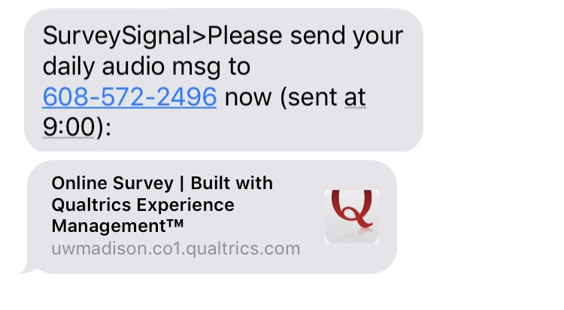

You do not have to click on the link to complete the audio message. If you do click on the link it will show you this message:

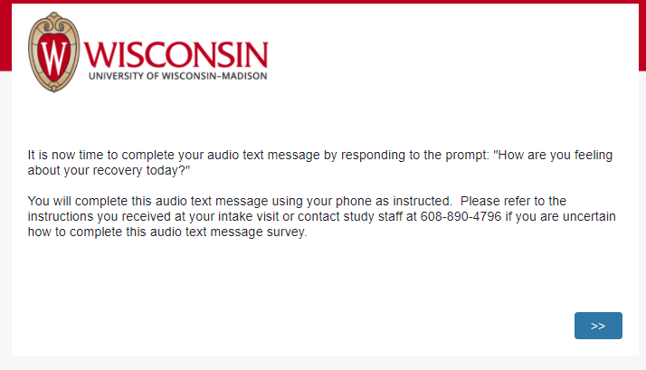

Follow these instructions to complete the Audio survey, as clicking the link only directs you to complete the survey as instructed below.

1. Save the phone number (608-572-2496) in your Contacts under a title that you will remember (we suggest labeling it Audio Survey)

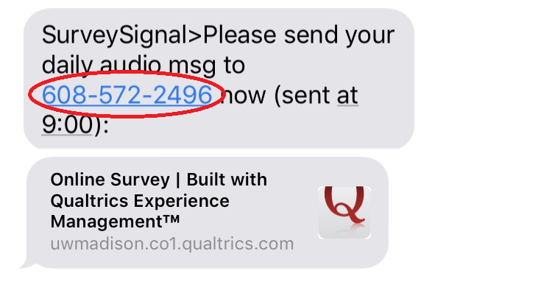

1. When you are ready to send your audio survey check-in click on the messages icon and click the compose message icon 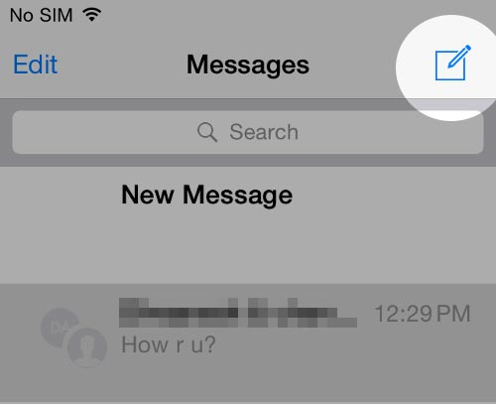

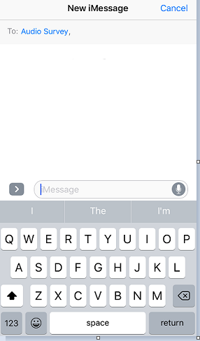

1. To start recording your audio message press and hold the microphone icon

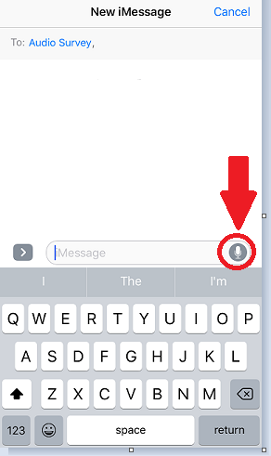

Your audio message needs to be between 15-30 seconds long, and you must press and hold the microphone icon throughout your audio message to keep recording.

1. When you are finished recording you will see a screen like this

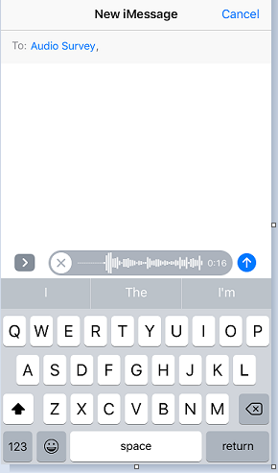

1. If you are satisfied with your message you can send it by clicking the blue and white arrow (indicated in red below). If you want to re-record your audio message you can press the x (indicated in black below) to re-record your message, simply press and hold the microphone icon again

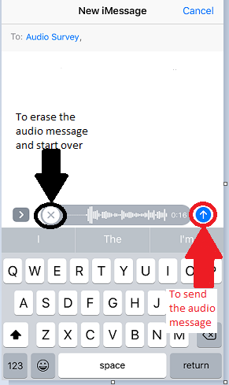

1. You will see in your Messages that an audio message was sent to the Audio Survey number

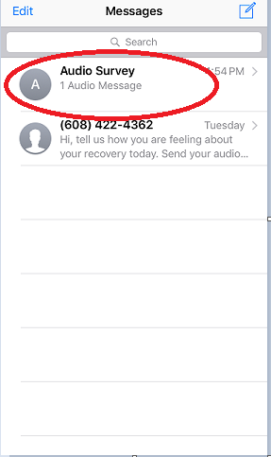

When you open the Audio Survey message you will see something like this:

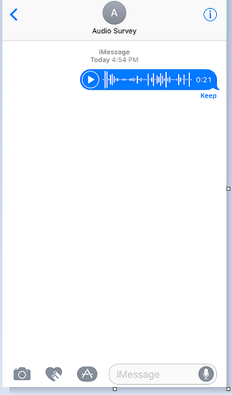

Once you’ve verified it’s sent you can delete the message. That’s it! If you have any questions feel free to call us at 608-890-4796.